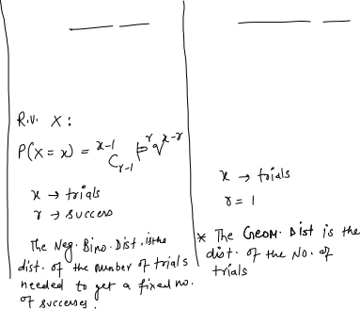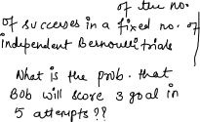

1. There is a probability of 0.261 that a bulb is fused. Suppose that the bulbs are shipped to retail outlets in boxes of 20 bulbs.
   1. What is the distribution of the number of fused bulbs in a box?



* 1. What the expected number of fused bulbs in a box?
  2. ﻿What is the probability that a box contains no more than three fused bulbs?

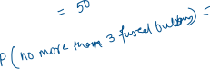

1. Investments are made in ten companies, and for each company there is a probability of 0.65 that the investment will deliver a profit. What is the probability that at least half of the investments will deliver a profit?



1. Cards are chosen randomly from a pack of cards with replacement. Calculate the probability that:

(a) The first heart is obtained on the third drawing.



(b) The fourth heart is obtained on the tenth drawing



(c) What is the expected number of cards drawn before the fourth heart is obtained?

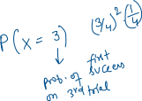

1. A fair coin is tossed until the fifth head is obtained. What is the probability that the coin is tossed exactly ten times?

